Using the Fuel Poverty and Health e-learning course (with Learning Management System)
1 Enter the link: http://www.elearning-nea.co.uk to access the courses. You will be presented with other courses on the LMS.
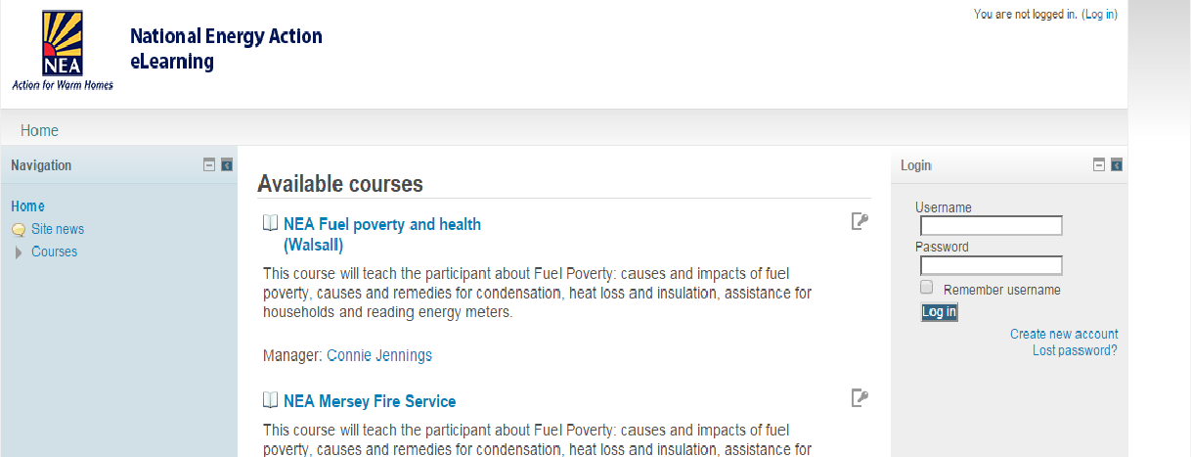
2 New users need to create a new account
3 The following screen opens:
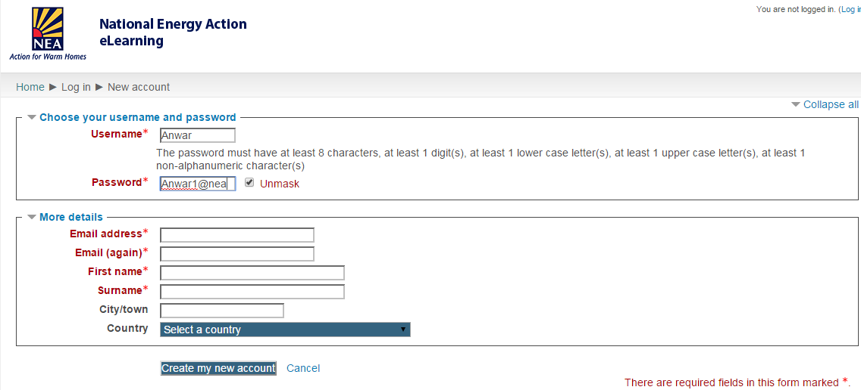
Enter details for a user name and password and the details underneath.
4 The screen shot below appears when registration has been successful.
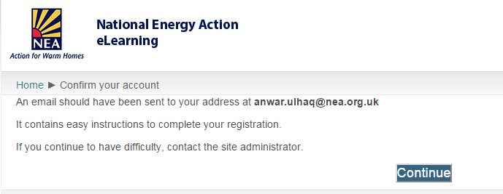
5 You will receive an email to the address typed in at stage 4 above:
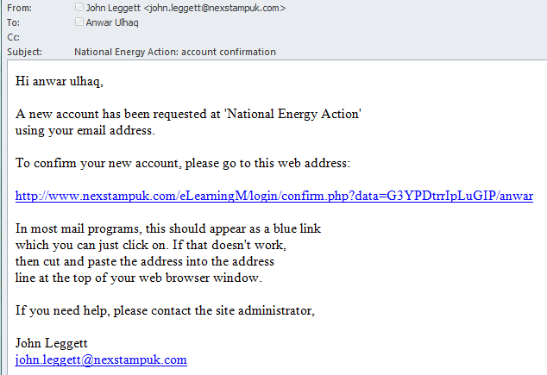
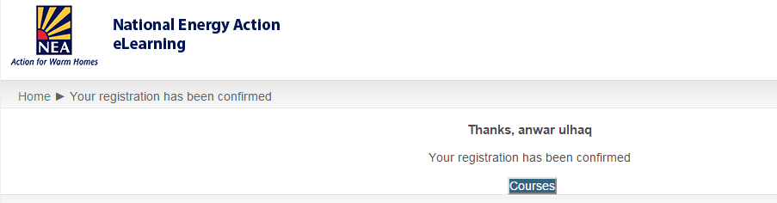
6. When clicking on the link above, you’ll get a confirmation as shown below:

7. When you click on courses, it will show you the list of courses on the LMS, one of which will be for Viridis.
8. Login using your username and password.

